IUPUI

IUPUI Faculty Council (IFC)
Committee Manual

2023-2024

Office of the Faculty Council

Table of Contents
IFC Committee Structure 3
Committee Charges 3
Procedures 7
Appointment 7
Committee Assignments 7
Meetings 7
Agendas, Minutes, and Information Items 7
Reports 7
Policy Approval and Endorsements 8
Committee Chair Responsibilities 8
Committee Member Responsibilities 9
Administrative Member Responsibilities 9
Executive Committee Liaison Responsibilities 9
Committee Assignment Dashboard 9
Contacts 13

IFC Committee Structure

Faculty governance for the IUPUI campus operates through the IUPUI Faculty Council (IFC). The IFC is composed of elected members and ex officio members. It is guided by a faculty president and vice president with an Executive Committee elected from its ranks by the council. IFC committees assist the council in their work with policy review and campus initiatives.

IFC committees are comprised of IFC members, faculty volunteers (tenure-track and non-tenure-track), staff, and students.

The IFC has the following committees to help guide its work:

Academic Affairs
Athletic Affairs
Board of Review Pool
Budgetary Affairs
Campus Planning
Constitution and Bylaws / Faculty Guide
Diversity, Equity, and Inclusion
Faculty Affairs
Faculty and Staff Relations
Fringe Benefits
Library Affairs
Nominating Committee
Ombudsteam
Online Education
Promotion and Tenure
Student Affairs
Student Appeals Pool
Technology

Committee Charges

The following are the charges to the IFC Committees.

ACADEMIC AFFAIRS COMMITTEE
This committee shall make recommendations to the Council on matters relating to general, not school specific, educational curriculum matters, establishing and revising academic calendars, degree formats, graduation requirements, the academic structure of IUPUI, and other related matters. This committee shall act in alignment with the diversity, equity, and inclusion strategic priorities of IUPUI. The Executive Committee of the IUPUI Faculty Council may appoint one or more students as non-voting members of the standing committee. The Executive Committee of the IUPUI Faculty Council shall make this appointment based on nominations submitted by the Undergraduate Student Government and Graduate Student Organization.

ATHLETIC AFFAIRS COMMITTEE
This committee participates in the development of general athletics policies related to academic matters, team competition, and practice schedules within the scope of athletics conference and association rules. The committee collaborates with administrators, coaches, and staff to promote diversity, equity, and inclusion within athletics and ensures appropriate educational opportunities on these subjects are offered to IUPUI student athletes. The committee participates in the approval of plans for addition/elimination of sports and plans for significant modification of athletics facilities. The Chancellor shall appoint the IUPUI Athletic Affairs Committee on the recommendation of the IUPUI Faculty Council Executive Committee. The Committee shall consist of seven voting members. The Committee's voting membership shall have a majority of faculty.

BOARD OF REVIEW POOL
A Faculty Board of Review is to consider grievances, via a Formal Hearing, to gather appropriate information, and to consider its findings in light of existing policies and principles of fairness.

BUDGETARY AFFAIRS COMMITTEE
This committee shall act as a representative of the Council in offering to the IUPUI Chancellor and the Campus Administration its continuing advice and the faculty perspectives on all aspects of the IUPUI budgetary policy and the allocation of the IUPUI financial resources, especially those proposed allocations and re-allocations of financial resources that have bearing on the overall economic well-being, equity, and fairness for the faculty and the academic programs, and possible ramifications for the achievement of the campus mission.

CAMPUS PLANNING COMMITTEE
Composition: This committee works to facilitate involvement and communication between the Faculty Council, Executive Committee, Budgetary Affairs Committee, and committees and academic units concerning institutional planning and improvement at IUPUI.
Duties: Duties. Broad faculty involvement in institutional planning is valued. The Committee is not itself the faculty planning body, but works to facilitate involvement and communication between the Faculty Council, Executive Committee, Budgetary Affairs Committee, and committees and academic units concerning institutional planning and improvement at IUPUI that ensures an equitable outcome for all campus and community stakeholders. This Committee shall be responsible for continued communication with the Administration, particularly the Senior Advisor to the Chancellor for Planning and Institutional Improvement.

CONSTITUTION AND BYLAWS COMMITTEE (Committee charge to be revised to include DEI.)
This committee shall periodically review the Constitution and Bylaws, draft revisions when necessary and provide, in conjunction with the Parliamentarian, interpretations of those documents when questions arise.

DIVERSITY, EQUITY, AND INCLUSION COMMITTEE
This committee is to advise and make recommendations to the IFC and campus leadership on issues relative to promoting and ensuring diversity, equity, and inclusion. To accomplish this charge, the committee shall have, but will not be limited to, the following duties: 1) Promote the recruitment, hiring, retention, and advancement of diverse faculty and staff; 2) Advocate for increased recruitment, enrollment, retention, and graduation of students from diverse backgrounds and experiences; 3) Disseminate information and successful practices related to diversity, equity, and inclusion in higher education; 4) Ensure the availability of mentoring opportunities for diverse faculty; 5) Review and make recommendations based on campus DEI plans and reports; 6) Provide guidance to academic and support units with their DEI plans upon request; 7) Provide a representative/liaison to meetings of the Chancellor’s Diversity Cabinet and the Vice Chancellor’s Diversity Group; and 8) Encourage campus development of DEI education and training opportunities for faculty, staff, and students.

EXECUTIVE COMMITTEE
This committee shall (1) determine the agenda for its own meetings and for regular meetings of the council; (2) solicit, with the help of the Faculty Council director, the interest of faculty in serving on IUPUI Faculty Council Standing Committees by the middle of March; (3) serve as the Committee on Committees for the council; (4) promote diversity, equity, and inclusion for all faculty, regularly reviewing progress toward goals; (5) conduct the elections which are governed by the provisions of the Faculty Council Bylaws, and rule on matters of dispute relating to election procedures; (6) determine the proper apportionment of unit representatives among the academic units, in accordance with the Bylaws; (7) and perform such other duties as may be assigned to it by the council or by the council’s Bylaws

FACULTY AFFAIRS COMMITTEE
This committee shall advise the Council on all matters that pertain to the responsibilities, rights, privileges, opportunities, and welfare of the faculty, collectively and as individuals, including but not limited to, issues of equity, academic freedom, appointments, and tenure and promotion policies and procedures.

FACULTY AND STAFF RELATIONS COMMITTEE
This committee shall be responsible for setting up the two Constitutionally-mandated annual joint meetings in conjunction with the Staff Council's Faculty Relations Committee. This committee shall serve in conjunction with the Staff Council's Faculty Relations Committee as a clearinghouse for information of common interest including, but not limited to, shared issues of equity, morale, health, safety, community, human resources, and compensation. The Committee shall, when necessary, meet independently to formulate faculty positions on faculty-staff matters.

FACULTY GUIDE COMMITTEE (Committee charge to be revised to include DEI.)
This committee shall be responsible for developing the IUPUI Faculty Guide as a supplement to the Indiana University Academic Policies. This committee then shall review the IU Policies and the IUPUI Faculty Guide annually and make recommendations concerning revisions to the Faculty Guide to the Faculty Council.

FRINGE BENEFITS COMMITTEE
This committee shall be responsible for reviewing needs unique to the IUPUI campus and recommending to the Council policies to deal with such needs and shall participate in policy development and ongoing reviews of fringe benefits matters affecting overall well-being, equity, and fairness for faculty and staff and the total Indiana University system.

LIBRARY AFFAIRS COMMITTEE (Committee charge to be revised to include DEI.)
This committee shall review and advise the Council on policies and resources of the IUPUI University Library. It shall also consider issues that might affect the quality of the campus libraries. This committee may serve as a forum for the discussion of existing or proposed policies and for the critique of planning and budgetary proposals. The Executive Committee of the IUPUI Faculty Council may appoint one or more students as non-voting members of the standing committee. The Executive Committee of the IUPUI Faculty Council shall make this appointment based on nominations submitted by the Undergraduate Student Government and Graduate Student Organization.

NOMINATING COMMITTEE
This committee shall: (1) solicit and receive from members of the faculty nominations for at-large representatives to the IUPUI Faculty Council and for members of the University Faculty Council; (2) nominate members of the faculty and librarians for elections by the Faculty Council to the positions of President and Vice-President of the Faculty, membership on the Executive Committee, membership on the Nominating Committee, at-large membership on the IUPUI Promotion and Tenure Committee, and membership in the pool for appointment to Faculty Boards of Review; (3) ensure that nominations received for each election promote diversity, equity, and inclusion with regular assessment of progress; (4) verify in every case that any nomination is made with the prior consent of the person(s) nominated; and (5) oversee the election of the at-large IUPUI representatives and the UFC representatives. The members of the IUPUI Ombudsteam shall be nominated by the Executive Committee for election by the Faculty Council at their May meeting.

OMBUDSTEAM
The IUPUI Ombudsteam is an elected faculty group designed to be available early on in the course of emerging concerns or potential grievances. It is further designed to provide designated places and persons for faculty to voice concerns and learn about options for channeling criticisms and addressing complaints so that faculty can be fully informed about possible actions and consequences before they make a decision as to what steps, if any, to take next.

ONLINE EDUCATION COMMITTEE
This committee represents the IUPUI Faculty Council and advises and acts as liaison with administration as well as faculty and other units concerned with online education. It aims to improve and promote online education, making use of best practices and frameworks, and coordinating resources available with the IUPUI Faculty Council Technology Committee, the Center for Teaching and Learning, UITS, the Office of Online Education, and individual schools. The committee supports faculty teaching online, provides online education assessment guidelines, and assists in ensuring inclusive and accessible learning for all students.

PROMOTION AND TENURE COMMITTEE - AT-LARGE REPRESENTATIVES
This committee shall: (1) monitor the promotion and tenure policies of the University and recommend, as may be desirable from time to time, such modifications as the Faculty Council may seek thereof; (2) recommend on the promotion and tenure of those candidates who are presented for consideration by the schools or libraries (voting shall be my secret ballot, and the results recorded for each candidate); (3) review, as needed or requested, methods to establish primary and unit promotion and tenure committees, and, when such methods are deemed to be deficient, recommend changes to the schools or libraries; (4) review, as needed or requested, primary and unit level procedures for promotion and tenure and, when such procedures are deemed deficient, recommend changes to the schools or libraries; (5) review, as needed or requested, documents which specify standards that are used at the primary, unit, and campus levels to evaluate whether candidates meet the criteria for tenure and promotion and, when such documents are deemed deficient, recommend changes to the schools, libraries, or campus; (6) establish such internal committee procedures as may be necessary to assist the committee and the Dean of the Faculties in providing for reviews of candidates for promotion and tenure, and; (7) receive requests from any faculty member or librarian, if appropriate, investigate and evaluate the promotion and tenure process of any department or unit, and make a written report to the faculty member or librarian making the request and to the department chairperson or the chief administrative officer of the unit.

RESEARCH AFFAIRS COMMITTEE
This Committee shall periodically review research policies and procedures, draft revisions when necessary, and provide interpretations about those policies and procedures when questions arise. The Committee shall include faculty members from a broad range of schools across campus reflecting both faculty and student research interests and artistic/scholarly activities. The Committee shall coordinate its activities with other relevant committees with a goal of improving the environment for research at IUPUI. The Committee shall support the goal of fostering diverse, equitable, inclusive, and just research endeavors by IUPUI faculty, staff, and students. The Committee shall be responsible for continued communication with the administration through the IUPUI Vice Chancellor for Research.

STUDENT AFFAIRS COMMITTEE (Committee charge to be revised to include DEI.)
This committee shall review and make recommendations to the Council regarding matters involving student affairs. The committee shall provide advice and guidance to the Vice Chancellor for Student Life and Diversity and to the Dean of Students in the area of student administrative and campus life services. The committee shall maintain liaison with IUPUI student governing bodies. The committee membership shall include two full-time students: one enrolled as an undergraduate and one enrolled in either the Graduate School or one of the graduate professional programs. Appointments of student members will be made from nominations submitted to the Executive Committee of the IUPUI Faculty Council by the IUPUI Undergraduate Student Assembly and the Graduate Student Organization. Student members shall have the same responsibilities and privileges as the other members of the Student Affairs Committee.

STUDENT APPEALS POOL (University Hearing Commission)
The Dean of Students selects from this pool when necessary to constitute a hearing commission in response to an appeal by a student (see Part V.G. of the Code of Student Rights, Responsibilities, and Conduct found at http://life.iupui.edu/rights/).

TECHNOLOGY COMMITTEE
This committee shall examine overall planning, use, and funding of technology at IUPUI; and advise and act as liaison with administration, as well as faculty and other technology committees including those which are university-wide (e.g., University Faculty Council, University Information Technology Services). The committee shall strive to make recommendations supporting equity, inclusion, and the diversity of IUPUI’s faculty, staff, and students. The Executive Committee of the IUPUI Faculty Council may appoint one or more students as non-voting members of the standing committee. The Executive Committee of the IUPUI Faculty Council shall make this appointment based on nominations submitted by the Undergraduate Student Government and Graduate Student Organization.

Procedures

The following are a general guide of how committees are appointed and perform their work:

Appointment
Committees are appointed by the IFC Executive Committee (IFC-EC). A survey is sent to both tenure track and non-tenure-track faculty in the spring to gauge interest in membership. The IFC-EC appoints the committees at their meetings in May. The IFC office invites faculty to membership during the summer to prepare for work to begin in the fall. Additional members may be added to a committee after work has commenced. Contact the council office (fcouncil@iupui.edu) to request additional members. Committee chairs may also inform the council office of persons they wish to add.

Committee members are appointed for a two-year term. A committee member may serve three consecutive two-year terms. After three terms, a member must sit out for one year before rejoining the same committee. They may serve on other committees during the one-year hiatus as long as they are eligible.

Committee chairs are appointed by the IFC-EC.

An IFC-EC member is appointed as liaison for each committee. Committees should not meet without their liaison present. The liaison can communicate committee work back to the IFC-EC during their business meetings if information is needed to assist in an agenda item.

Committee Assignments
Assignments are given to the committees by the IFC-EC at the chair’s orientation in September. Assignments are added by the IFC-EC throughout the year as initiatives are brought to the council. Committees may also develop their own work to report to the council.

Committee assignments can be accessed in the Committee Assignments dashboard (https://facultycouncil.iupui.edu/FcCommitteeAssignments). Instruction on how to use the dashboard to update the assignment status can be found on page 8.

Meetings
Committee meetings are held when a majority of the members are able to meet. The committee chair arranges for the meetings. Committees should not meet without their IFC-EC liaison or administrative liaison (if appointed) present. A committee member should be appointed by each committee to record minutes. None of the liaisons should be tasked with recording the minutes for meetings. They are present to provide information to you or back to the Executive Committee or other committee. The council office does not provide clerical support to committees.

Committee chairs meet with the IFC-EC throughout the academic year including the chair’s orientation in September and in the spring semester to report on the work of the committees. The committee also presents at least once during an IFC meeting to provide an update to the full council.

Agendas, Minutes, and Information Items
Agendas, minutes, and any items the committees use to develop policy or inform their discussion should be uploaded to the committee’s folder in MS Teams. Information stored in the account is owned by the IFC and is archived. Committees should not set up independent Teams/OneDrive accounts. All committee members are given access to the Teams folder.

Reports
An annual report is provided by the committee at the close of the academic year.

Committee assignments can be accessed in the Committee Assignments dashboard (https://facultycouncil.iupui.edu/FcCommitteeAssignments). Instruction on how to use the dashboard to update the assignment status to prepare the annual report can be found on page 8.

Policy Approval and Endorsements
Committees that suggest new policy, changes to current policies, or endorsement of an initiative by the council should follow these steps:

- Ideas for action by the IFC can originate in task forces, administrative offices, or in IFC standing committees. For ideas that come from non-standing committees, the IFC-EC will determine which IFC standing committee or committees should be involved.
- Committee or task force chair or administrative office contacts the council office (fcouncil@iupui.edu) to be scheduled for an IFC-EC meeting. Changes to policy, etc., must first be vetted through the IFC-EC before taking it to the full council for endorsement. The IFC-EC can either approve the item for IFC endorsement or take it back to the committee for changes.
- If approved by the IFC-EC, the committee chair (or representative) is scheduled for an IFC meeting to present the initiative. This is considered a first read. A second meeting is scheduled (usually the following month) for a vote.
- If changes are suggested, the committee chair/representative takes the suggestions back to the committee/office for revision. The IFC-EC may suggest an IFC committee work with another IFC committee on the revisions. When the revisions have been made, the chair/representative schedules another meeting with the IFC-EC (see #2).
- Once a proposal is approved, its content will be incorporated into the IUPUI Faculty Guide or other such procedural or policy documents as the IFC-EC determines. Material for the Faculty Guide is coordinated with the IFC Faculty Guide Committee. Parties affected by the change or endorsement are notified by the council office.

Committee Chair Responsibilities

Committee Chair Responsibilities:

- Attend the chairs orientation in September to receive assignments from IFC-EC.
- Schedule committee meetings at a time when it is convenient for most members to attend. IFC-EC liaisons and administrative liaisons (if appointed) should be in attendance at meetings.
- Appoint a member to record the minutes of each meeting. Meeting minutes must be uploaded to the council-appointed MS Teams folder. They may also be sent to the council office for archiving.
- Notify the council office if additional committee members are needed.
- Address as many of the assignments given to the committee as possible. You are encouraged to create your own assignments as well. Executive Committee assignments are just a starting point.
- Attend a meeting of the IFC-EC in the spring semester to provide an update on committee work.
- Present to the full council initiatives that need endorsement by the council. (See Policy Approval and Endorsements under Procedures. It takes at least three steps for an initiative to be endorsed or approved by the council.)
- Record attendance of members. At the end of the year, send a letter of acknowledgement and thanks to each member who fully participated. If any persons did not meaningfully participate, send a request to the IFC-EC that they not be reappointed to the committee.
- Provide an update on committee work to the full council once per academic year.
- Request assistance from the IFC-EC or other committees as needed.
- Turn in annual report to the council office by June 30 through the committee dashboard.

Committee Member Responsibilities

Committee Member Responsibilities:

- Attend as many meetings of the committee as possible.
- Engage in discussion.
- Notify the chair as soon as possible if you are unable to complete your term.
- Assist the committee chair in their duties.

Administrative Member Responsibilities

Administrative Member Responsibilities:

- Attend as many meetings of the committee as possible.
- Engage in discussion.
- Provide consultation or advice regarding initiatives the committee is considering. Report concerns to the IFC-EC if necessary.

Executive Committee Liaison Responsibilities

Executive Committee Liaison Responsibilities:

- Attend as many meetings of the committee as possible.
- Engage in discussion.
- Provide consultation or advice regarding initiatives the committee is considering. Report concerns to the IFC-EC if necessary.
- Share committee initiatives with the IFC-EC as agenda items are discussed that pertain to it. Provide feedback to the committee.
- Do NOT volunteer to serve as a minute-taker for committees. Committee members should fill this role.

Committee Assignment Dashboard

Use these instructions to find committee assignments, update their status, and file your committee’s annual report. Questions? Contact Karen Lee at klee2@iupui.edu.

- Access the Committee Assignments Dashboard: https://facultycouncil.iupui.edu/FcCommitteeAssignments

- To find your committee, use either the up or down arrows to sort by committee (scrolling through the alphabetical list to find your committee information) or use the search box in the upper right corner to narrow down the search.

If using the search box, be sure to click on the page numbers in the bottom menu to see all your assignments. They may be on one or more pages.

- Once your committee assignments appear, click on the Review/Edit button (far right) for each item to update the assignment.

  - Your assignment will appear on a new screen.

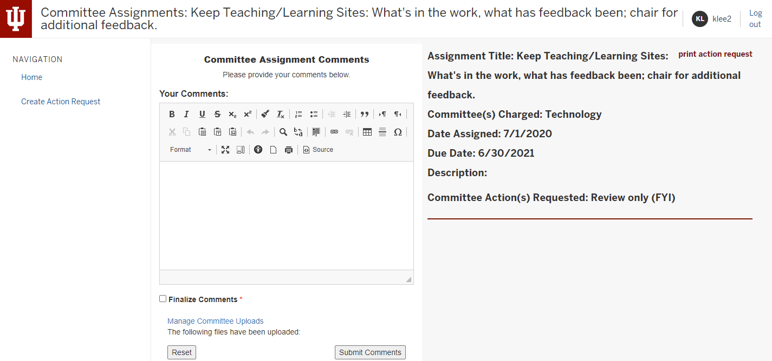

  - The assignment is listed on the far right showing what the assignment is (Assignment Title), committee charged to take care of the assignment, date assigned, due date, a description (if any), and an action to take.
  - In the Committee Assignment Comment box (middle of the screen), provide information about what your committee did for that assignment to complete it.
  - Upload any documentation (e.g., proposed policy or documentation for review) by clicking on Manage Committee Uploads under the comment box.

- Click on Finalize Comments ONLY if the assignment is complete. Otherwise, go to step 5. If Finalize Comments is not checked, it signals the IFC office that the assignment will be carried over to the next year.

- Click on Submit Comments.

- Proceed to next assignment.

Choose Create Action Request if you would like to add an item your committee completed during the year that does not appear on the list. Follow these steps:

- On the main Committee Assignments screen (https://facultycouncil.iupui.edu/FcCommitteeAssignments), click on Create Action Request.

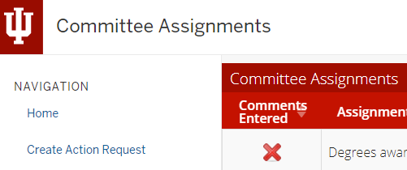
- Complete the following fields (see page 11 for example screen):
  - Request Title: (Required) Enter the main point of the assignment. Example: Review Article 2, Section 1 of the Code of Student Ethics.
  - Committee(s) Charged: (Required) Select your committee from the drop-down menu.
  - Date of Request: (Required) Enter the date you entered the assignment. The default is the first day of the academic year.
  - Suggested Response Date: (Required) Enter the date by which you will finish the assignment. The default is the last day of the academic year.
  - Brief Description of Initiative: Enter a description of what the assignment entails.
  - Manage Request Documents: Upload documentation about the assignment.
  - Committee Action(s) Requested: (Required) Select from the drop-down menu what action you will take.
  - Click on Submit Action Request.

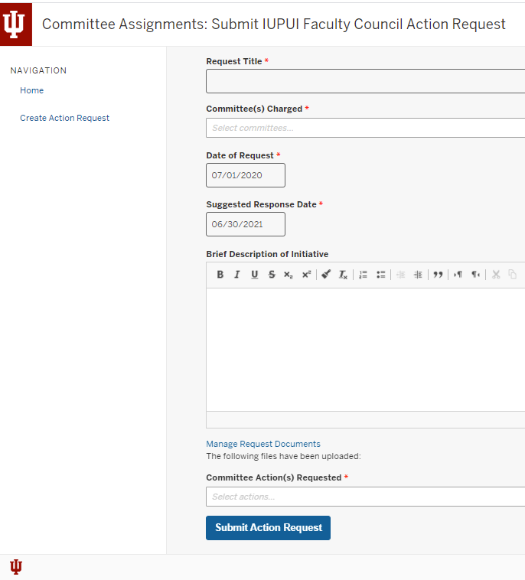

Contacts

IUPUI Faculty Council Office
317-274-2215
fcouncil@iupui.edu

IFC President
fcouncil@iupui.edu

Myra Carleton
Administrative Assistant / IFC Committee Liaison
317-274-8424
mtcarlet@iu.edu

Karen Lee
Director of Academic Personnel Policies and Services
317-274-2215
Klee2@iupui.edu

